3rd Annual Walkway Marathon Race Series will to include College to College 5K Scheduled for June 10 & 11, Races Feature William R. Steinhaus Dutchess Rail Trail

Plans are on the way for the 3rd Annual Walkway Half and Full Marathon and the College to College 5K, on Sunday, June 11, 2016. In addition to a marathon, half-marathon and the Think Differently Dash, the 2017 Walkway Marathon Race Series will feature the College to College 5K in collaboration with Dutchess Community College. The 5K will begin at Dutchess Community College and then head south on Creek Rd to the DRT/Morgan Lake Trail Head. Runners will then run on Fairview Ave to West Cedar and finish at the Marist College Waterfront. More than 2,500 runners, walkers, and wheelchair athletes are expected to compete in one of four races. The courses will use, in part, the Walkway Over the Hudson State Park, as well as the William R. Steinhaus Dutchess Rail Trail.

Even if you are not a runner, there are many ways to be a part of this exciting community event. To learn more about the Walkway Marathon- to sign up to volunteer, to register for one of the four running events, or to learn about sponsorship opportunities please visit http://walkwaymarathon.org/. or call: 845-454-9649.

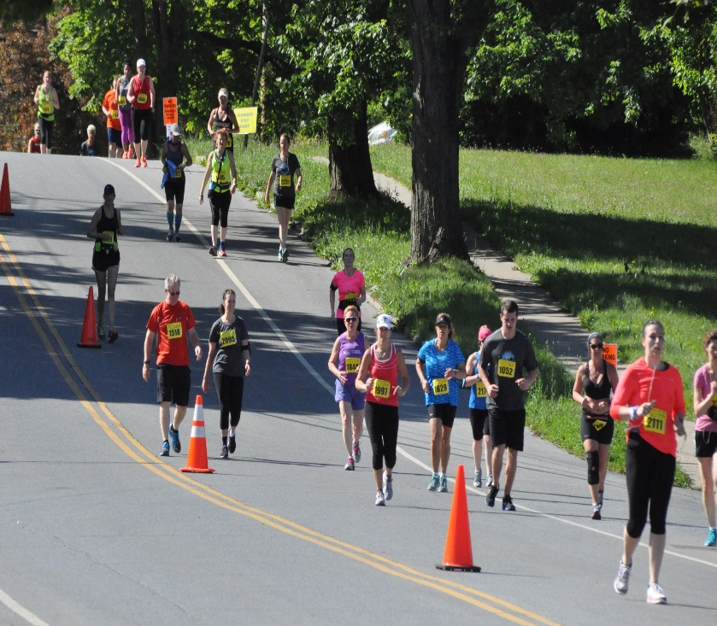 Photo credit Kelly Igoe.

